INTERNAL COMPONENTS AND WORKING FLOW

INTRODUCTION:
Inside a computer mouse are key components like a circuit board (PCB), an optical sensor (LED/laser & CMOS camera) to track movement, micro switches for clicks, a scroll wheel with an encoder for scrolling, and a processor chip, all connected to communicate with the computer, either via a cable or wireless receiver, with wireless versions also needing a battery and transmitter.
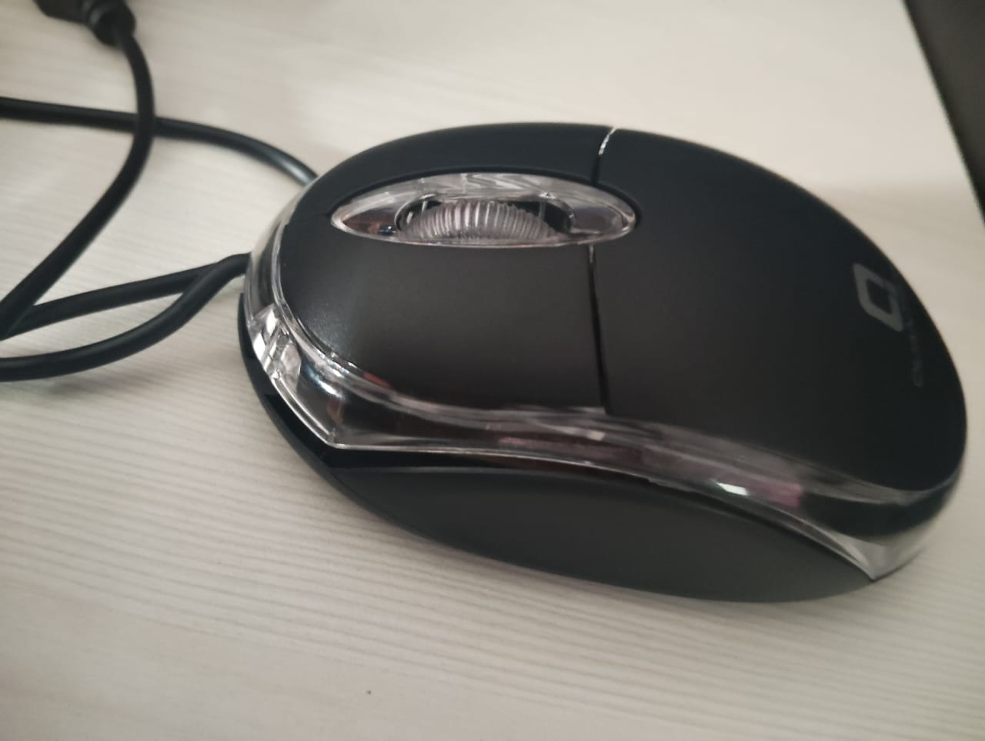
INTERNAL BLOCK DIAGRAM :
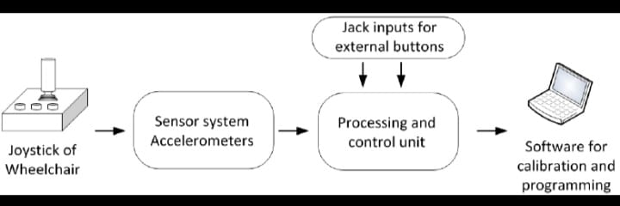

A computer mouse block diagram shows its core parts: Physical Controls (buttons, scroll wheel), an Optical/Laser Sensor, a Microcontroller (processes clicks/movement), a Memory (settings), and a Communication Interface (USB/Wireless) sending data (X/Y coordinates, clicks) to the PC, translating user actions into digital commands.
Here's a typical flow:
- User Interaction: You move the mouse (X/Y motion) or click buttons/scroll.
- Sensing: The optical/laser sensor tracks surface movement, while switches detect clicks/scroll.
- Signal Generation: These inputs create electrical signals.
- Microcontroller Processing: The internal chip interprets signals (e.g., "Left Click," "Move Right 5 Pixels").
- Data Formatting: Data is put into packets (coordinates, button states).
- Transmission: The interface (USB cable or wireless module) sends this data to the computer.
- Computer Interpretation: The PC receives data and the OS translates it to screen actions (cursor movement, opening menus).

INTERNAL COMPONENTS :
- USB cable connections
- Optical sensor IC
- LED light source
- Scroll
- Printed circuit board (PCB)
- wheel with rotary encoder
- Microswitch (click button)
- Capacitor and small passive components
- 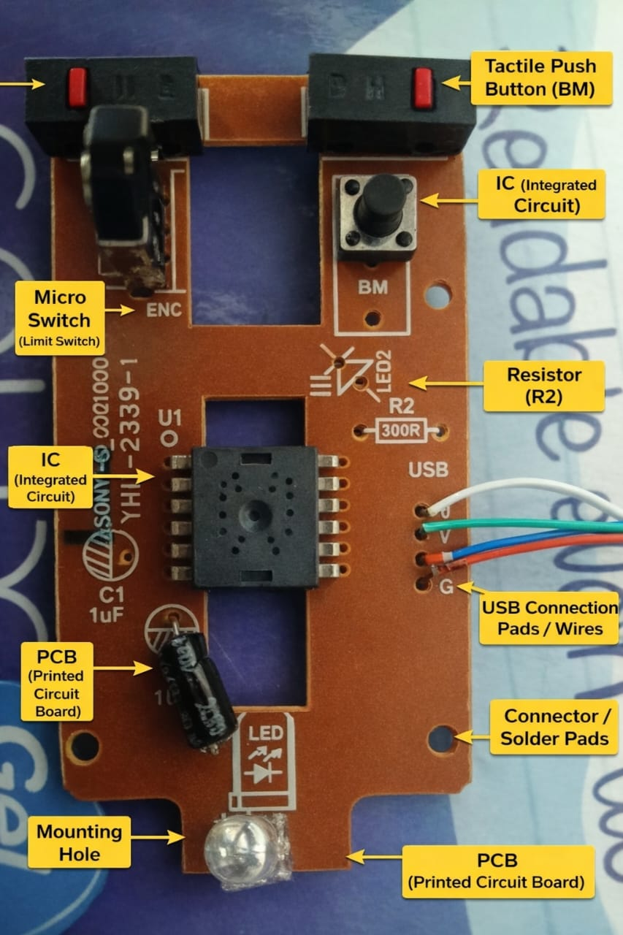

- Printed Circuit Board (PCB): The main "brain" of the mouse, this board connects all the components and processes signals before sending them to the computer. It contains a microprocessor/microcontroller chip.
- Optical Sensor (or Laser Sensor): This is the most critical part. It detects movement by capturing images of the surface beneath the mouse and comparing them to determine direction and speed.
- LED Light (or Infrared Light): The light source (often red or blue) that illuminates the surface so the sensor can track movement effectively.
- Micro Switches: These small mechanical (or sometimes optical) switches are located under the left and right buttons (and often the scroll wheel). They register your clicks and send the corresponding signals to the circuit board.
- Scroll Wheel Assembly (Rotary Encoder): The mechanism that detects the rotation of the scroll wheel. It uses an encoder to measure the direction and speed of scrolling and often acts as a third, clickable button.
- Cable or Wireless Transceiver:
  - For wired mice, a USB cable carries power and transmits data signals to the computer.
  - For wireless mice, a radio frequency (RF) transceiver chip sends and receives wireless signals to a USB receiver plugged into the computer, and a battery management system handles power from an onboard battery.

CIRCUIT DIAGRAM FOR MOUSE

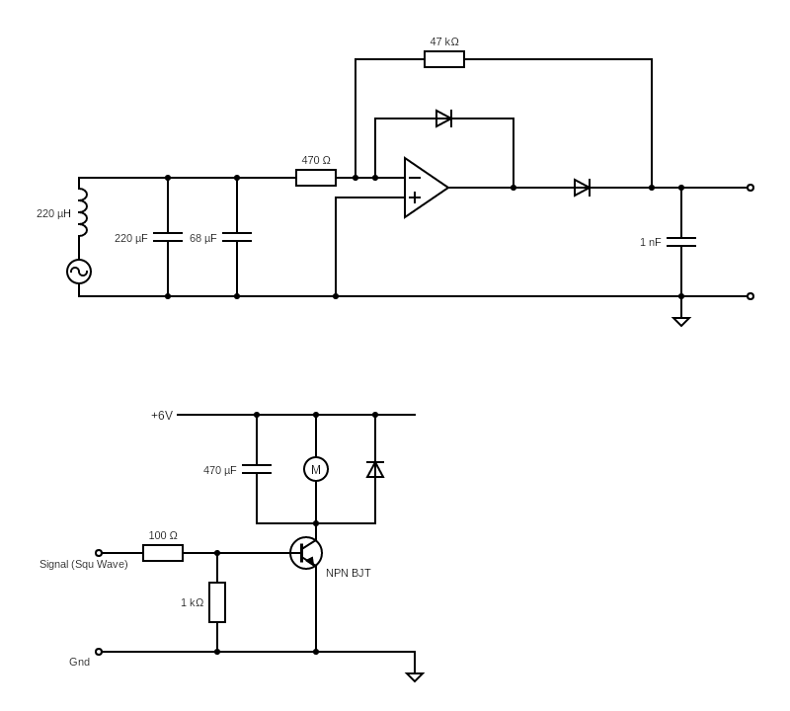

DETAILED EXPLANATION
A computer mouse is a handheld pointing device that translates physical hand movements into cursor movements on a screen, allowing users to interact with graphical interfaces by clicking, dragging, and scrolling icons, files, and text. Modern mice use optical or laser sensors to track motion, feature left/right buttons for selection and context menus, and a scroll wheel for navigating documents, connecting via USB or wirelessly. Invented by Douglas Engelbart, it's a fundamental input tool for tasks from web browsing to graphic design.

1)Core Components & Functions
- Left Button (Primary): Used for selecting items, opening files (double-click), and dragging objects.
Right Button (Secondary): Opens context menus with additional options (copy, paste, properties).
Scroll Wheel: Rotates to move up/down pages, can often be clicked to open links in new tabs or access navigation tools.
- Pointer/Cursor: The arrow/icon on the screen that moves in sync with the mouse.

2)How It Works (Modern Optical/Laser)
- Motion Detection: A light (LED or laser) illuminates the surface; a sensor (CMOS sensor) captures images of the surface texture.
- Image Processing: An internal digital signal processor (DSP) compares successive images to detect direction and speed of movement.
- Signal Transmission: This movement data is converted into digital signals and sent to the computer via USB (wired) or wireless signal (Bluetooth, RF).
- Cursor Movement: The computer's software translates these signals to move the on-screen cursor accordingly.

3)Types & Connections
- Wired: Connects via USB cable, draws power from the computer, no batteries needed.
- Wireless: Uses radio frequency (RF) or Bluetooth, requires batteries (disposable or rechargeable).
- Other Types: Includes trackballs, touchpads (on laptops), and specialized gaming/ergonomic mice.

4)Common Operations & Gestures
- Point: Move the mouse to position the cursor over an item.
- Click: Press the left button once to select/activate.
- Double-Click: Quickly click the left button twice to open a file/program.
- Drag: Hold the left button down while moving to move or copy objects.
- Right-Click: Access options menu.
- Scroll: Use the wheel to view content that doesn't fit on screen.

